6A – Driving – Lesson 03
Cost & Purchase of Insurance – Theft and Insurance.

Name: _________________
- Find the theft rating of a Subaru Forester X.
www.nrma.com.au/keeping-safe-secure/car-safety/car-theft-ratings/

Break in Resistance ___/100 Theft Resistance ___/100

Vehicle ID ___/100 Scored ___/120

- Find the theft rating of another car. ___________________?

Break in Resistance ___/100 Theft Resistance ___/100

Vehicle ID ___/100 Scored ___/120

- Use the graph below to answer the following questions.
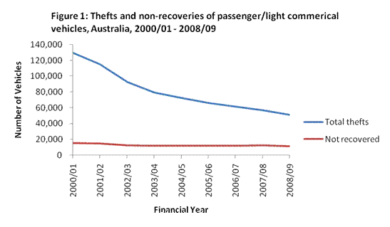
- How many cars were stolen in 2000/01? __________

- How many cars were stolen in 2008/08? __________

- Why do you think there may have been a drop in the number of cars stolen over the eight years?

- Are most cars recovered?
- Use the graph below to answer the following questions.
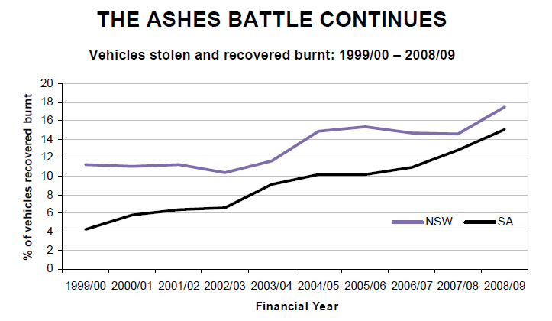
- How many cars in NSW were recovered burnt in 2000/01? ________

- How many cars in NSW were recovered burnt in 2008/09? ________

- Why would the number of burnt cars gone up when the number of stolen cars has gone down?

- List two reasons a car could be burned?

- Why would there be more cars stolen and burnt in NSW than SA?

- What will the effect of an increase in stolen cars have on premiums?

- What other factors do you think may affect the premiums for car insurance?

